L2 Helper v1.1.0

Introduction

L2 Helper is simple and primitive Lineage II bot. It has capabilities to read data from L2 client and simulate keypresses. The source code has address pointers hardcoded, which will not work often on different machines. However, the app has simple way to disable feature of reading player data, and can continue to function with only reading target HP values. It is enough if no healing is required (grinding on easy spots).

Setup L2 clients

Place Clients on the left side of screen (required for not reading party members HP bars as target HP bar)

F1 – next target  
F2 – auto attack  
F11 – assist

Other skills vary by class  
F10 -buff/dance

System for reading data from files (now is hardcoded) and customizing button layout will be added in later versions.

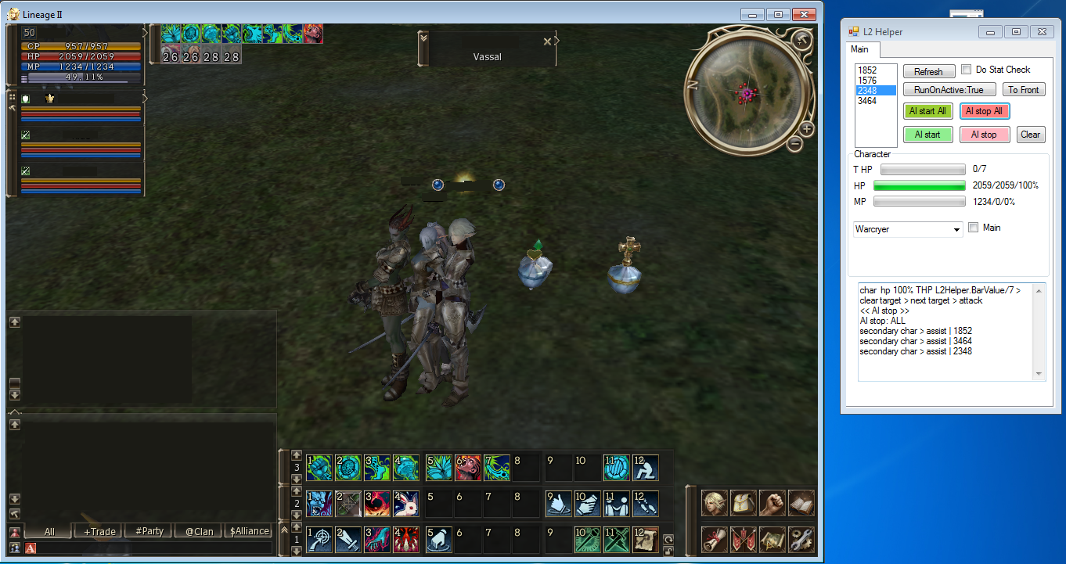

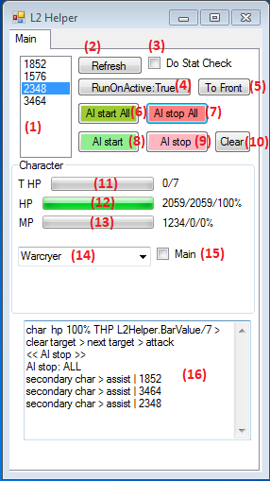Setup app  
List (1) has all the process Id’s for Lineage II instances listed.  
Do this with each process:

1. select process in the list
2. press button (5) to bring client to front
3. select class (14). If it is simple character with no special skills that only need auto attacking, this step can be skipped
4. check if this going to be the main character (the one which everyone will assist)

After you have 1 character that will be main, and selected appropriate classes for supports, press button (6) to start botting.

If you prefer to play one character yourself, press button (4) to set it to “false” so that the main window is not controlled by AI.